1a)

|  |  |  |  |  |  |
| --- | --- | --- | --- | --- | --- |
| A | B | C | A AND B | NOT C | (A AND B) AND (NOT C) |
| 0 | 0 | 0 | 0 | 1 | 0 |
| 1 | 0 | 0 | 0 | 1 | 0 |
| 0 | 1 | 0 | 0 | 1 | 0 |
| 1 | 1 | 0 | 1 | 1 | 1 |
| 0 | 0 | 1 | 0 | 0 | 0 |
| 1 | 0 | 1 | 0 | 0 | 0 |
| 0 | 1 | 1 | 0 | 0 | 0 |
| 1 | 1 | 1 | 1 | 0 | 0 |

1b)

|  |  |  |  |  |  |  |
| --- | --- | --- | --- | --- | --- | --- |
| A | B | C | NOT C | B AND (NOT C) | NOT (B AND NOT C) | A AND (NOT B AND NOT C) |
| 0 | 0 | 0 | 1 | 0 | 1 | 0 |
| 1 | 0 | 0 | 1 | 0 | 1 | 1 |
| 0 | 1 | 0 | 1 | 1 | 0 | 0 |
| 1 | 1 | 0 | 1 | 1 | 0 | 0 |
| 0 | 0 | 1 | 0 | 0 | 1 | 0 |
| 1 | 0 | 1 | 0 | 0 | 1 | 1 |
| 0 | 1 | 1 | 0 | 0 | 1 | 0 |
| 1 | 1 | 1 | 0 | 0 | 1 | 1 |

1c)

|  |  |  |  |  |  |  |
| --- | --- | --- | --- | --- | --- | --- |
| A | B | C | NOT B | A OR (NOT B) | A OR C | (A OR NOT B) AND (A OR C) |
| 0 | 0 | 0 | 1 | 1 | 0 | 0 |
| 1 | 0 | 0 | 1 | 1 | 1 | 1 |
| 0 | 1 | 0 | 0 | 0 | 0 | 0 |
| 1 | 1 | 0 | 0 | 1 | 1 | 1 |
| 0 | 0 | 1 | 1 | 1 | 1 | 1 |
| 1 | 0 | 1 | 1 | 1 | 1 | 1 |
| 0 | 1 | 1 | 0 | 0 | 1 | 0 |
| 1 | 1 | 1 | 0 | 1 | 1 | 1 |

1d)

|  |  |  |  |  |  |  |  |  |  |  |
| --- | --- | --- | --- | --- | --- | --- | --- | --- | --- | --- |
| A | B | C | D | NOT C | B OR (NOT C) | NOT (B OR NOT C) | NOT A | D AND (NOT A) | (D AND NOT A) AND (NOT B OR NOT C) | (D AND (NOT A AND NOT B OR NOT C) AND A |
| 0 | 0 | 0 | 0 | 1 | 1 | 0 | 1 | 0 | 0 | 0 |
| 1 | 0 | 0 | 0 | 1 | 1 | 0 | 0 | 0 | 0 | 0 |
| 0 | 1 | 0 | 0 | 1 | 1 | 0 | 1 | 0 | 0 | 0 |
| 1 | 1 | 0 | 0 | 1 | 1 | 0 | 0 | 0 | 0 | 0 |
| 0 | 0 | 1 | 0 | 0 | 0 | 1 | 1 | 0 | 0 | 0 |
| 1 | 0 | 1 | 0 | 0 | 0 | 1 | 0 | 0 | 0 | 0 |
| 0 | 1 | 1 | 0 | 0 | 1 | 0 | 1 | 0 | 0 | 0 |
| 1 | 1 | 1 | 0 | 0 | 1 | 0 | 0 | 0 | 0 | 0 |
| 0 | 0 | 0 | 1 | 1 | 1 | 0 | 1 | 1 | 0 | 0 |
| 1 | 0 | 0 | 1 | 1 | 1 | 0 | 0 | 0 | 0 | 0 |
| 0 | 1 | 0 | 1 | 1 | 1 | 0 | 1 | 1 | 0 | 0 |
| 1 | 1 | 0 | 1 | 1 | 1 | 0 | 0 | 0 | 0 | 0 |
| 0 | 0 | 1 | 1 | 0 | 0 | 1 | 1 | 1 | 1 | 0 |
| 1 | 0 | 1 | 1 | 0 | 0 | 1 | 0 | 0 | 0 | 0 |
| 0 | 1 | 1 | 1 | 0 | 1 | 0 | 1 | 1 | 0 | 0 |
| 1 | 1 | 1 | 1 | 0 | 1 | 0 | 0 | 0 | 0 | 0 |

2a)

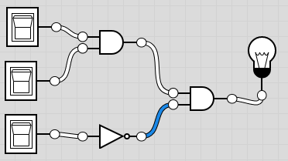

2b)

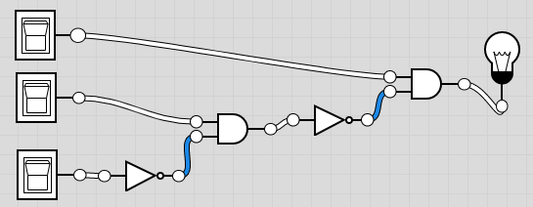

2c)

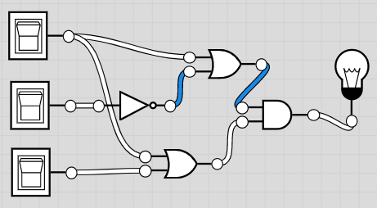

2d)

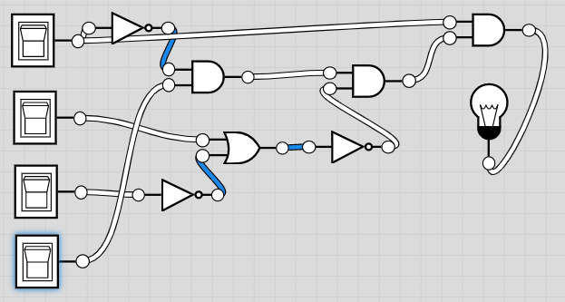

3a)

|  |  |  |  |
| --- | --- | --- | --- |
| A | B | A OR B | NOT (A OR B) |
| 0 | 0 | 0 | 1 |
| 1 | 0 | 1 | 0 |
| 0 | 1 | 1 | 0 |
| 1 | 1 | 1 | 0 |

|  |  |  |  |  |
| --- | --- | --- | --- | --- |
| A | B | NOT A | NOT B | (NOT A) AND (NOT B) |
| 0 | 0 | 1 | 1 | 1 |
| 1 | 0 | 0 | 1 | 0 |
| 0 | 1 | 1 | 0 | 0 |
| 1 | 1 | 0 | 0 | 0 |

3b)

|  |  |  |  |
| --- | --- | --- | --- |
| A | B | A AND B | NOT (A AND B) |
| 0 | 0 | 0 | 1 |
| 1 | 0 | 0 | 1 |
| 0 | 1 | 0 | 1 |
| 1 | 1 | 1 | 0 |

|  |  |  |  |  |
| --- | --- | --- | --- | --- |
| A | B | NOT A | NOT B | (NOT A) OR (NOT B) |
| 0 | 0 | 1 | 1 | 1 |
| 1 | 0 | 0 | 1 | 1 |
| 0 | 1 | 1 | 0 | 1 |
| 1 | 1 | 0 | 0 | 0 |

3c)

|  |  |  |  |  |  |
| --- | --- | --- | --- | --- | --- |
| A | B | C | A AND B | A AND C | (A AND B) OR (A AND C) |
| 0 | 0 | 0 | 0 | 0 | 0 |
| 1 | 0 | 0 | 0 | 0 | 0 |
| 0 | 1 | 0 | 0 | 0 | 0 |
| 1 | 1 | 0 | 1 | 0 | 1 |
| 0 | 0 | 1 | 0 | 0 | 0 |
| 1 | 0 | 1 | 0 | 1 | 1 |
| 0 | 1 | 1 | 0 | 0 | 0 |
| 1 | 1 | 1 | 1 | 1 | 1 |

|  |  |  |  |  |
| --- | --- | --- | --- | --- |
| A | B | C | B OR C | A AND (B OR C) |
| 0 | 0 | 0 | 0 | 0 |
| 1 | 0 | 0 | 0 | 0 |
| 0 | 1 | 0 | 1 | 0 |
| 1 | 1 | 0 | 1 | 1 |
| 0 | 0 | 1 | 1 | 0 |
| 1 | 0 | 1 | 1 | 1 |
| 0 | 1 | 1 | 1 | 0 |
| 1 | 1 | 1 | 1 | 1 |

3d)

|  |  |  |  |  |  |
| --- | --- | --- | --- | --- | --- |
| A | B | C | A OR B | A OR C | (A OR B) AND (A OR C) |
| 0 | 0 | 0 | 0 | 0 | 0 |
| 1 | 0 | 0 | 1 | 1 | 1 |
| 0 | 1 | 0 | 1 | 0 | 0 |
| 1 | 1 | 0 | 1 | 1 | 1 |
| 0 | 0 | 1 | 0 | 1 | 0 |
| 1 | 0 | 1 | 1 | 1 | 1 |
| 0 | 1 | 1 | 1 | 1 | 1 |
| 1 | 1 | 1 | 1 | 1 | 1 |

|  |  |  |  |  |
| --- | --- | --- | --- | --- |
| A | B | C | B AND C | A OR (B AND C) |
| 0 | 0 | 0 | 0 | 0 |
| 1 | 0 | 0 | 0 | 1 |
| 0 | 1 | 0 | 0 | 0 |
| 1 | 1 | 0 | 0 | 1 |
| 0 | 0 | 1 | 0 | 0 |
| 1 | 0 | 1 | 0 | 1 |
| 0 | 1 | 1 | 1 | 1 |
| 1 | 1 | 1 | 1 | 1 |

4a) NOT (A AND B) = (NOT A) OR (NOT B)

|  |  |  |  |
| --- | --- | --- | --- |
| A | B | A AND B | NOT (A AND B) |
| 0 | 0 | 0 | 1 |
| 1 | 0 | 0 | 1 |
| 0 | 1 | 0 | 1 |
| 1 | 1 | 1 | 0 |

|  |  |  |  |  |
| --- | --- | --- | --- | --- |
| A | B | NOT A | NOT B | (NOT A) OR (NOT B) |
| 0 | 0 | 1 | 1 | 1 |
| 1 | 0 | 0 | 1 | 1 |
| 0 | 1 | 1 | 0 | 1 |
| 1 | 1 | 0 | 0 | 0 |

4b) (A AND B) OR (C AND B) = (A OR C) AND B, where A is type(x) == int, B is x > 7 and C is type(x) == float

|  |  |  |  |  |  |
| --- | --- | --- | --- | --- | --- |
| A | B | C | A AND B | C AND B | (A AND B) OR (C AND B) |
| 0 | 0 | 0 | 0 | 0 | 0 |
| 1 | 0 | 0 | 0 | 0 | 0 |
| 0 | 1 | 0 | 0 | 0 | 0 |
| 1 | 1 | 0 | 1 | 0 | 1 |
| 0 | 0 | 1 | 0 | 0 | 0 |
| 1 | 0 | 1 | 0 | 0 | 0 |
| 0 | 1 | 1 | 0 | 1 | 1 |
| 1 | 1 | 1 | 1 | 1 | 1 |

|  |  |  |  |  |
| --- | --- | --- | --- | --- |
| A | B | C | A OR C | (A OR C) AND B |
| 0 | 0 | 0 | 0 | 0 |
| 1 | 0 | 0 | 1 | 0 |
| 0 | 1 | 0 | 0 | 0 |
| 1 | 1 | 0 | 1 | 1 |
| 0 | 0 | 1 | 1 | 0 |
| 1 | 0 | 1 | 1 | 0 |
| 0 | 1 | 1 | 1 | 1 |
| 1 | 1 | 1 | 1 | 1 |

4c) For the first set of code the program checks to see if x and y are equal to 0, if both are then the function “do_something” is activated, if x or y is not 0 then the program prints “Do nothing”. Where as in the second set of code the program checks if x and y are not 0, if they are not then the program prints “Do nothing”, if x and y are both 0 then the program actives the function “do_something”. So both programs active the same task but they both go about checking the conditions in different ways the first program checks for the condition first by using an if statement while the second program checks for the inverse of the condition by using an else statement.

4d) A OR (B AND C) = B AND (A OR C), where A is x>10, B is x>0 and C is y>0.

|  |  |  |  |  |
| --- | --- | --- | --- | --- |
| A | B | C | B AND C | A OR (B AND C) |
| 0 | 0 | 0 | 0 | 0 |
| 1 | 0 | 0 | 0 | 1 |
| 0 | 1 | 0 | 0 | 0 |
| 1 | 1 | 0 | 0 | 1 |
| 0 | 0 | 1 | 0 | 0 |
| 1 | 0 | 1 | 0 | 1 |
| 0 | 1 | 1 | 1 | 1 |
| 1 | 1 | 1 | 1 | 1 |

|  |  |  |  |  |
| --- | --- | --- | --- | --- |
| A | B | C | A OR C | B AND (A OR C) |
| 0 | 0 | 0 | 0 | 0 |
| 1 | 0 | 0 | 1 | 0 |
| 0 | 1 | 0 | 0 | 0 |
| 1 | 1 | 0 | 1 | 1 |
| 0 | 0 | 1 | 1 | 0 |
| 1 | 0 | 1 | 1 | 0 |
| 0 | 1 | 1 | 1 | 1 |
| 1 | 1 | 1 | 1 | 1 |